Install & User Guide - Quick Picture Add-on

Table of Contents

Installation 2

Placing Quick Picture on Product Form 4

Using Quick Picture to add pictures to a record. 6

Place Quick Picture on any other entity form 7

# Installation

1. Log in to your Microsoft Dynamics CRM 2011 instance as a System Administrator or System Customizer – Must have administrative privileges.
2. Navigate to Settings > Solutions and click on Import.
3. The next window that opens will let you browse for the solution you are importing – navigate to the QuickPic_2_0_managed file downloaded from Unizap website, select it and complete the import as shown here.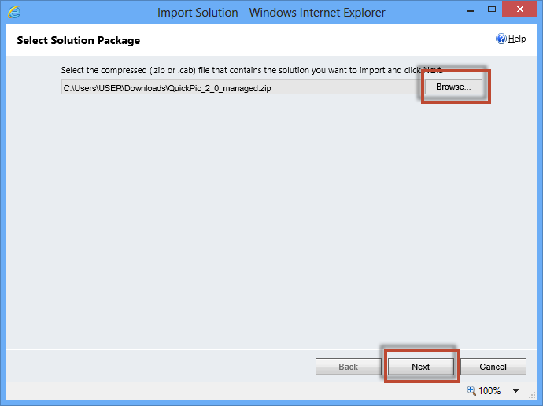

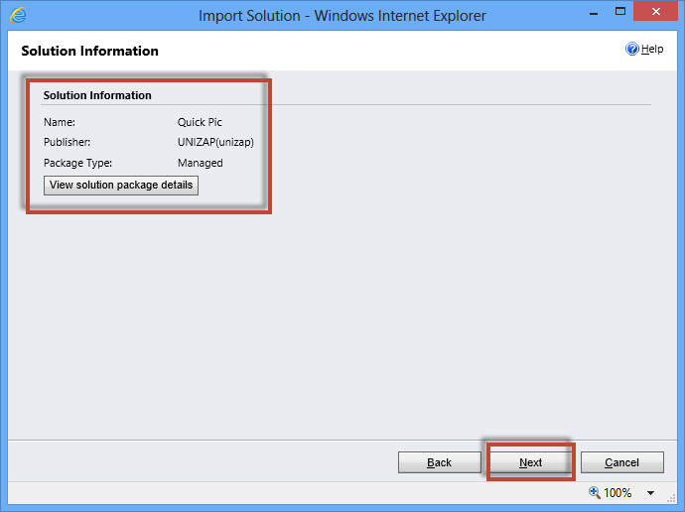

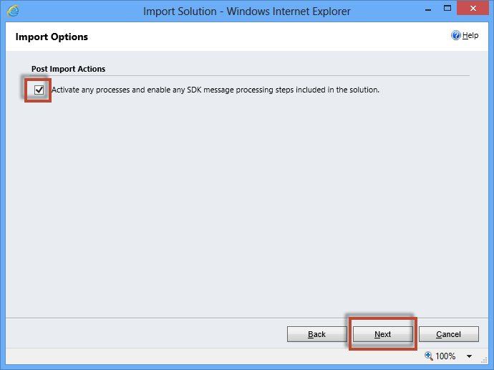

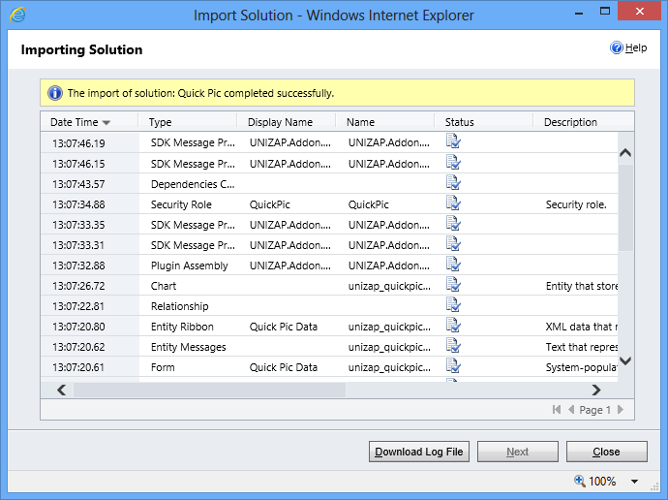

# Placing Quick Picture on Product Form

* Quick Picture Add-on lets you add photos to your CRM records.
* This is very useful when your users want to have a gallery of pictures which they can browse through directly on CRM form.

To place Quick Picture on Product Form please follow the steps below:

1. Open Form customization window in Product Entity & navigate to Insert Tab to insert a new Web Resource. Add *unizap_QuickPic.html as* shown in the following images.

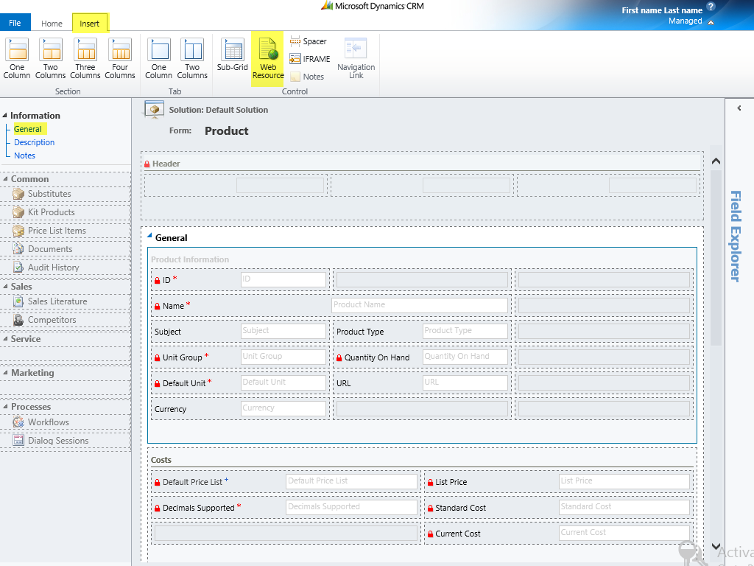

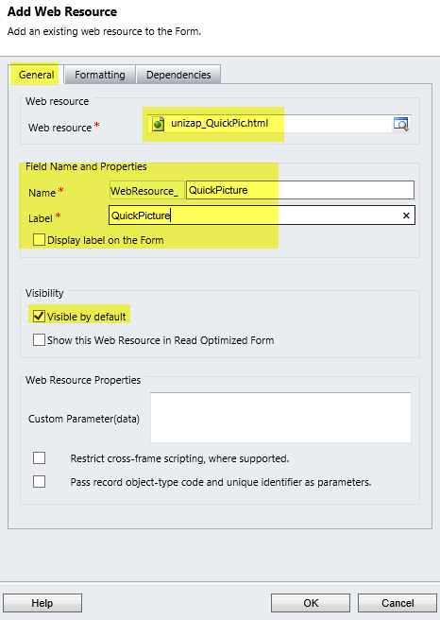 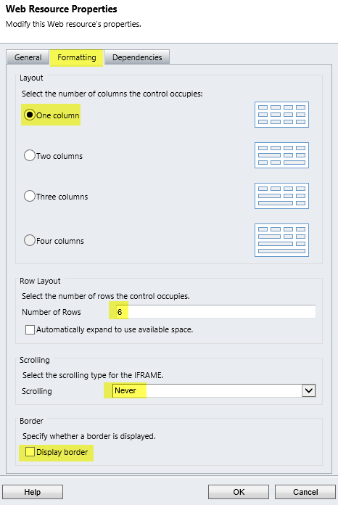

After you insert the Web Resource, the Product form should look like this. Save & Publish to continue.

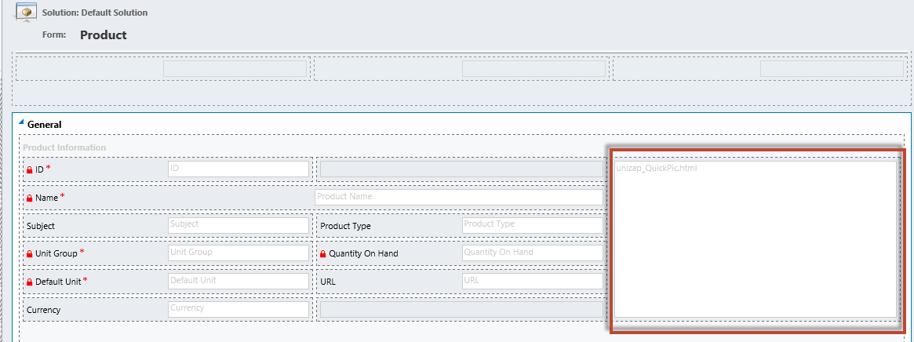

1. Now open any **existing** product record from your CRM system to see the Quick Picture Placeholder as shown here. Hover on the placeholder to get access to buttons as shown in the screen below.

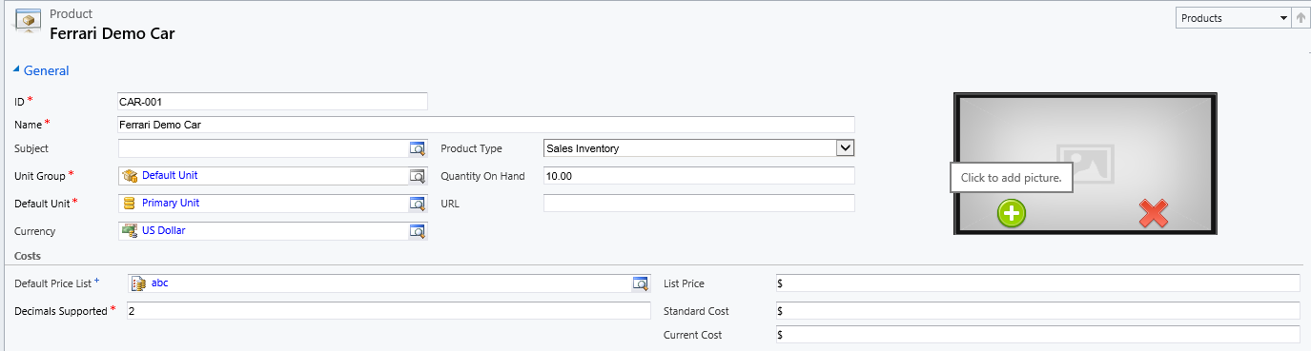

**Note: The Quick Picture placeholder will be visible only on existing records. You must save the new record first before adding a picture to that record.**

# Using Quick Picture to add pictures to a record.

**Note: To Add/Delete pictures, the user must be a System Administrator or must be assigned the *“QuickPic”* role which comes with the managed solution.**

1. Click on the green button to add picture. Select the picture to add it to the product record.

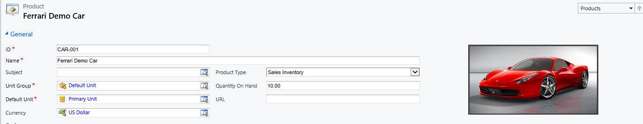

1. You may add more than one picture to any record. Click on green button to add another picture.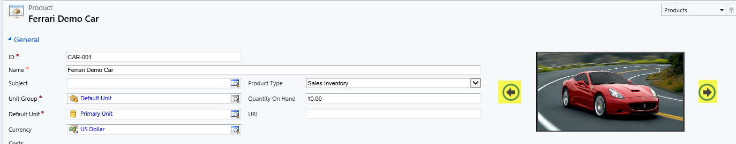

You may browse through the images using the left/right arrow buttons as highlighted above.

1. Click on the Red (Cross) button to delete the displayed picture.

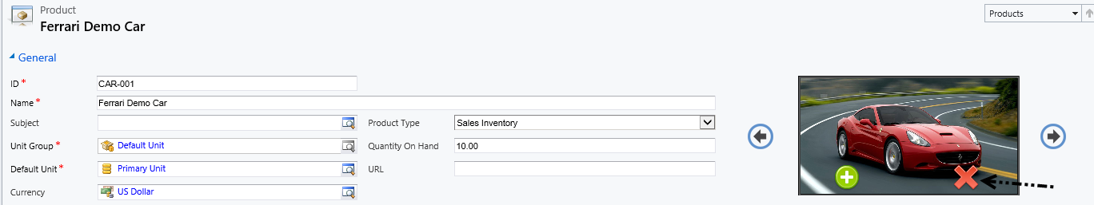

# Place Quick Picture on any other entity form

You can place Quick Picture on any CRM entity form.

1. Navigate to the entity you’d like to place it on and open any existing record or new record of that entity.
2. Click the Customize tab - >Customize Form.
3. Insert the web resource as explained earlier in this guide.
4. Choose no. of columns & no. of rows as required.
5. Once you click Ok, you will see the web resource on the form design view. You may drag it to any other position in the tab as desired.

**Note: The picture will be resized automatically based on the dimensions of the HTML web-resource. So, set the rows & columns of the web-resource accordingly.**